Project Future 12:
Data Engineering & Business Intelligence
Team 4 Project Report
Authors:
Georgios Kapelos, Dimitrios Loukakis, Ioannis Karelas,
Georgios Avgeridis, Anastasios Kakos

Project Outline
Our team was approached by Melodica Media Corporation, an online music store company headquartered in California, USA and was tasked with implementing an end-to-end Business Intelligence pipeline to analyze the company’s track sales in order to support the company towards optimizing the business decision-making process.

For the completion of this task, our team was provided with the Chinook OLTP database, which contained all the necessary transactional sales data. After importing the data, our team successfully developed a full data pipeline consisting of a Staging Area for reliable loading to a subsequent Data Warehouse database, which was used to create automated ETL processes leading to the creation of a comprehensive and interactive PowerBI dashboard.

The PowerBI dashboard focuses on making the user experience user friendly and delivering clear views of sales performance across multiple dimensions.

The OLTP Database
Our main source of data was the Chinook database, Melodica’s main transactional (OLTP) system. In order to best tackle the problem, the team initially studied the relationships (Normalization check) between the Tables of the OLTP database. This allowed us to focus on extracting the data according to relevance with the client’s business needs, which included mainly data from the Tracks, Invoices (Sales), Customers and Employee entities. A complete diagram of the OLTP database is provided below:
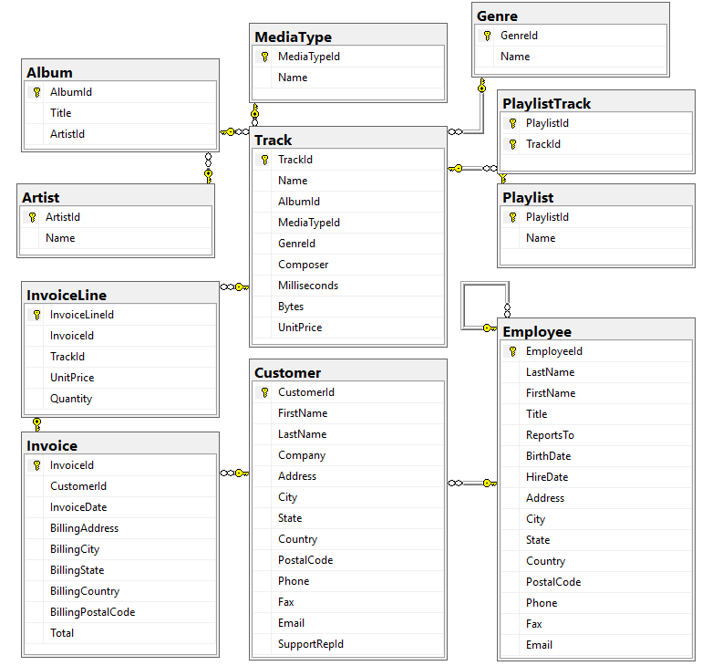
Figure 1: The OLTP database

Staging Area
The purpose of a Staging Area is to serve as a temporary landing zone for the data to be used for analysis. It consists of direct copies of the original data and allows for reliable loading to a Data Warehouse database (covered later), which is the core source of data for the final analysis dashboard.

Our team decided for the Staging Area to consist of 4 Tables, which aligned (when it comes to logic) with the focus entities described in the previous section, namely Customers, Employees, Sales and Track. The first two contained exact duplicates of data from the corresponding tables in the OLTP database, while the last two contained joined information from multiple tables. Specifically, for the Track staging area Table joins of the Album, Artist, MediaType, Genre and Track OLTP tables were used, while for the creation of the Sales staging area Table, data from Invoice and InvoiceLine OLTP Tables were utilized. All joins were performed on primary and foreign key agreements and attention was paid to avoid any possible loss of information, while discarding any unnecessary NULL rows.

A complete diagram of the Staging Area is provided below:

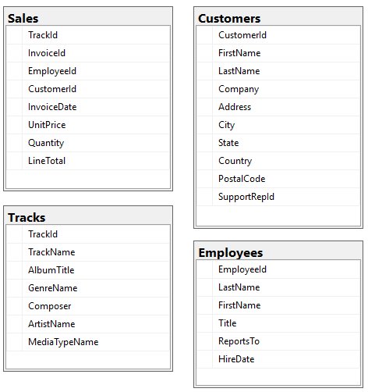
Figure 2: The Staging Area database

Data Warehouse
The Data Warehouse database served as the source for the analytics and performance reporting aspect of the project. Data from the Staging Area were pulled to create the database, while a STAR Schema model was utilized with the FactSales table being the centre of the Schema connected to the 4 additional dimension Tables, namely DimCustomer, DimEmployee, DimTrack and DimDate. Each table has its own new and unique (absent from the OLTP database) Primary Key used for relating the central FactSales Table with the rest, while the DimDate Table provides temporal information to conduct analytics based on time.

An analytical overview of the Data Warehouse database is provided in the form of a diagram below:

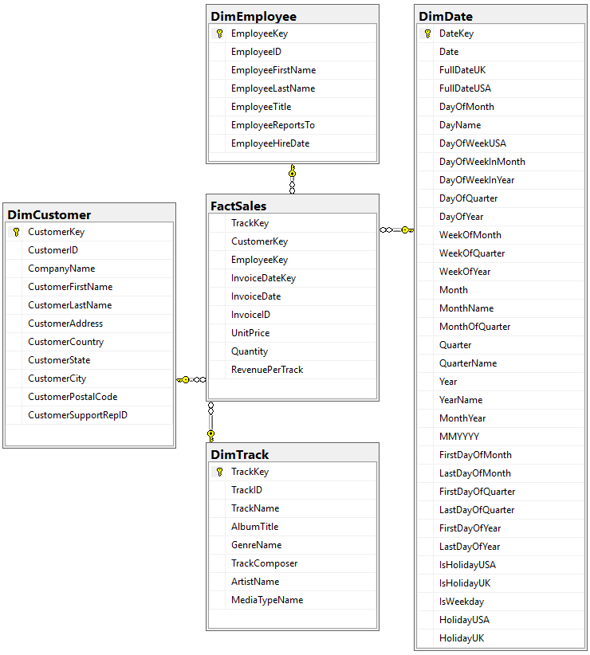
Figure 3: The Data Warehouse database

Power BI
The Power BI layer serves as the final, user-facing component of the solution and is built on top of the data warehouse. The dashboards are fully interactive, allowing users to filter the data and focus on specific time periods using year and date-based slicers.
It is structured into multiple pages, covering overall sales performance, time-based analysis, track and genre insights, customer behavior, and employee performance. This design enables users to explore the data at different levels of detail and easily compare trends across selected time ranges.By providing flexible time-based filtering and interactive exploration, the Power BI dashboards support clear, focused analysis and faster business insight generation without requiring direct access to the underlying data.

Future Improvement
Looking ahead, this project could be further improved by automating the ETL process using SSIS , to reduce manual effort and ensure more consistent data updates. Deploying the solution in a cloud environment would also make it more accessible and scalable as data volumes grow. Finally, adding what-if analysis and sales forecasting models could provide deeper insights and support more effective business planning.

